**Multibranch Pipeline with a Webhook on Jenkins**

Sometimes it may be necessary to create a pipeline on Jenkins for each Git branch. In this case it could be difficult to create independent pipeline for each branch. Besides that what if we create or delete a branch in future? So someone has to take care of the pipelines on Jenkins whenever there is change in branches. that's where Multibranch pipeline comes into picture.

Through Multibranch pipeline we can create a pipeline for each branch in a repository and it also create or remove when there is a change in the branches. Let’s see how it works !!

**Pre-Requisites:**

1. Expected a Jenkins server is already up and running
2. A Git repository with more than one branch

I

**Create a Multibranch Pipeline**

1. Login to Jenkins GUI
2. Click on “New Item” → Specify a job name → Select “Multibranch Pipeline option”

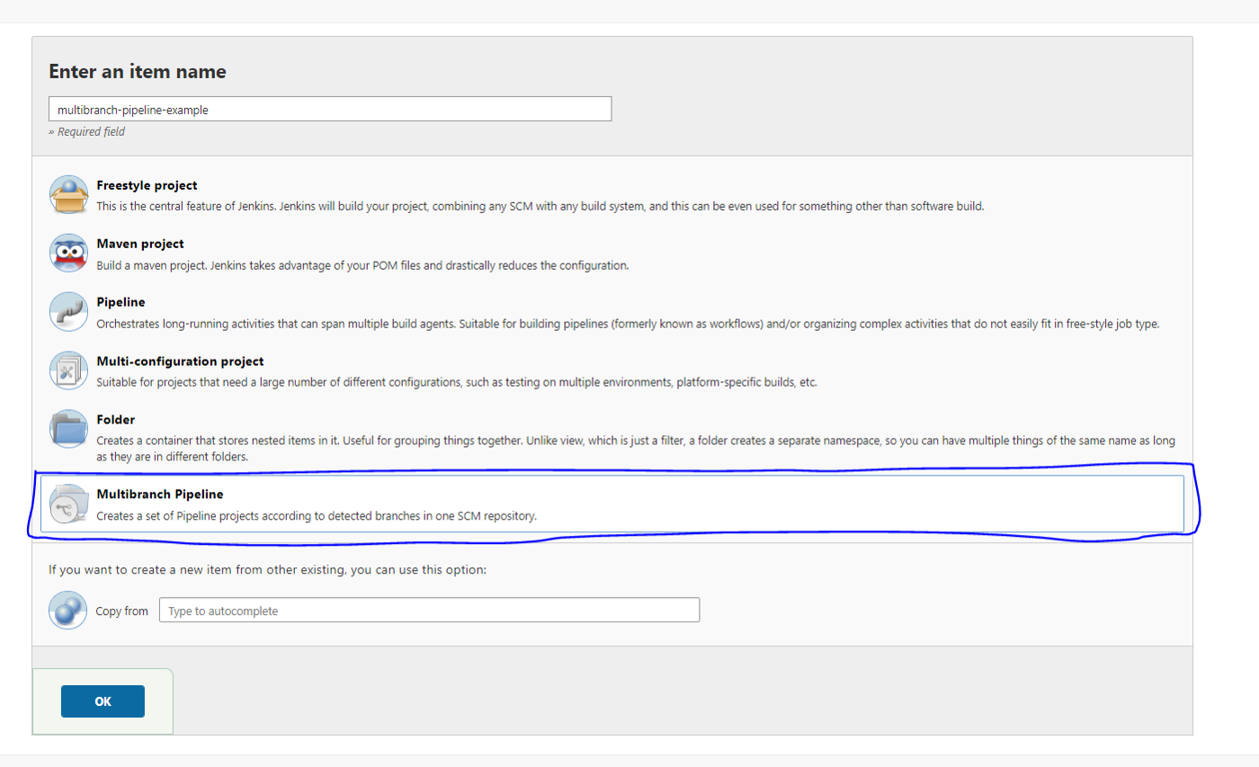

3. Give Display Name and Description

4. Under Branch Sources → Add source → Chose Git → and provide GitHub URL and Credentials (Credentials are optional if it is public repo)

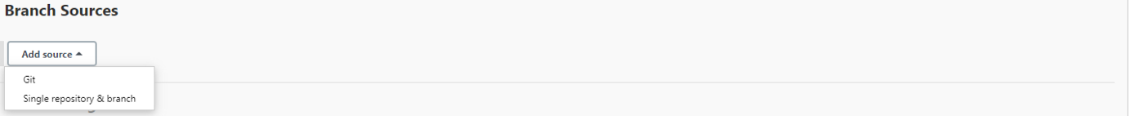

Branch Source Image

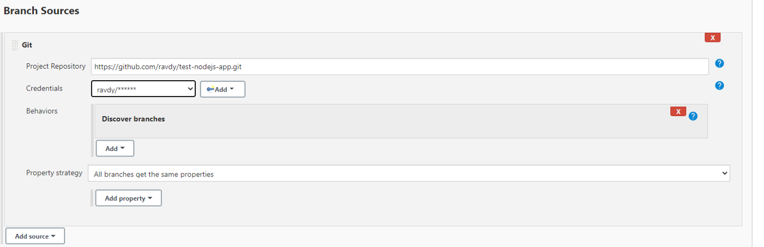

Git Repo Information

5. Under Build Configuration → chose Jenkinsfile path. Most of the case it will be under Repo root directory.

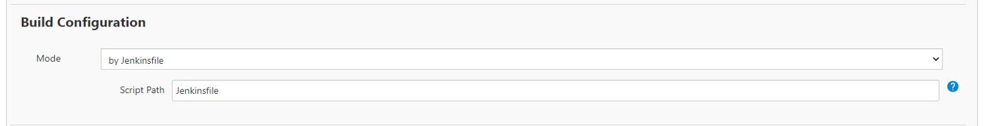

Jenkinsfile path

6. Apply and Save the job

Now Jenkins automatically scans the repository and create a job for each branch wherever it finds a Jenkinsfile and initiate first build.

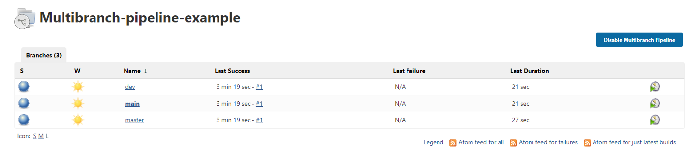

Multibranch Pipeline

**Using Webhook**

If you wish to automate the build process in the multibranch pipeline we can use Webhook. This feature is not enabled until we install “Multibranch Scan Webhook Trigger”. This enables an option “scan by webhook” under “Scan Multibranch Pipeline Triggers”. Here we should give a token. I am giving it as “mytoken”. by this time your job looks something like below.

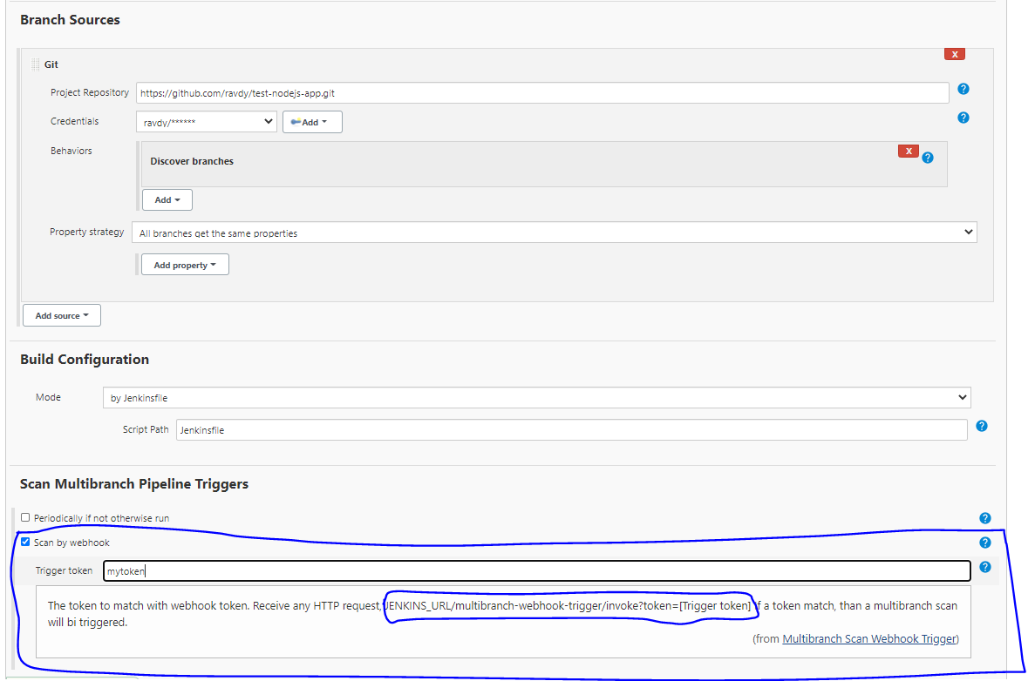

Jenkins Multibranch pipeline with webhook

Now to enable auto build process we should provide Jenkins URL with token in the GitHub. in this case like should be <http://65.0.130.108:8080/>multibranch-webhook-trigger/invoke?token=mytoke

for this log into GitHub → settings → Webhooks → Add webhook

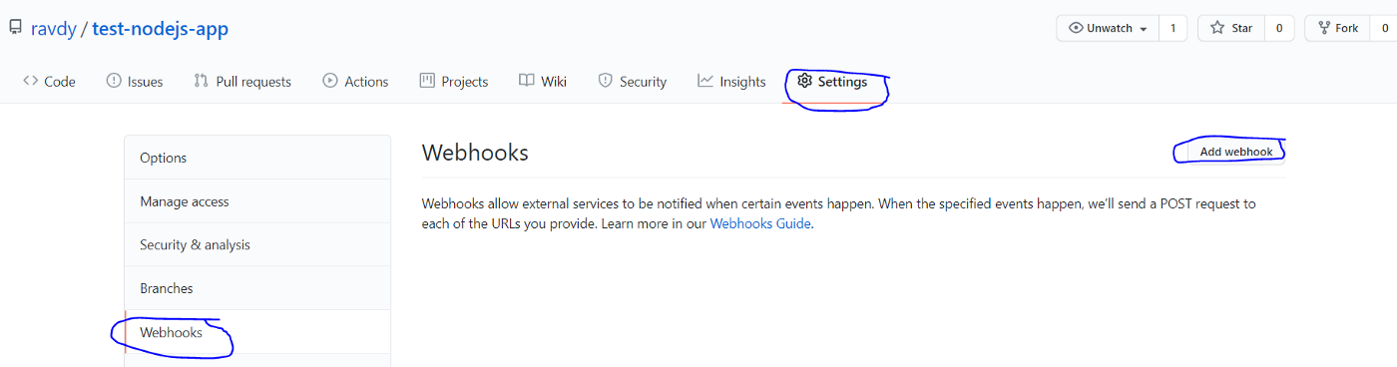

Provide Payload URL as “<http://65.0.130.108:8080/>multibranch-webhook-trigger/invoke?token=mytoke” and Content type as “application/json” and click on Add webhook

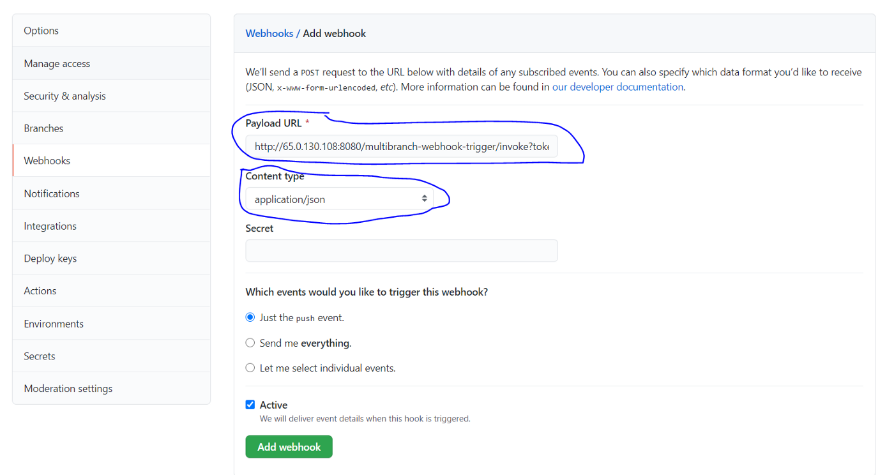

Once this is done you can see a new webhook and its time to do some changes in the repository to test the webhook connection.

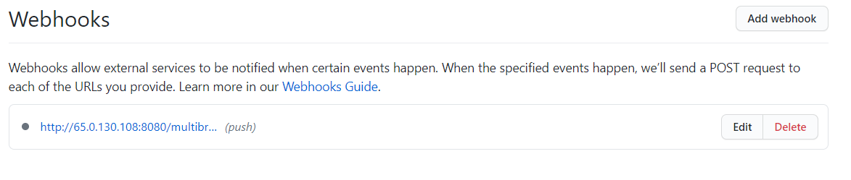

In this demonstration, I am going to create a new branch called “stage” and push the changes onto remote repo.